CRYSTAL PALACE BOWMEN

BEGINNERS’ COURSE APPLICATION FORM

Thank you for your interest, and welcome to Crystal Palace Bowmen.

The course costs £80 and comprises of six consecutive sessions over 6 weeks. The costs cover all the equipment required as well as coaching fees, insurance etc.

There is a minimum age of 10 years, although this is at the discretion of the club as some juniors under that age are more physically developed than others. All Juniors on the course must be accompanied by their parent / guardian at all times. All our coaches are fully qualified by Archery GB and are subject to strict Enhance DBS checks.

Please bring an umbrella as there is limited shelter. If the weather is so bad on any evening that we cannot shoot that session will be added on to the end of the course.

The venue is the Old Dunstonian’s sports ground, which is best reached by turning into St. Dunstan’s Lane from Wickham Way. Please note:- there is no vehicular access from South Eden Park Road past Langley Park School. The post code BR3 3SS and WhatThreeWords are: ///shot.backup.bath

If you would like to join the course, please complete the form below and return it as soon as possible as places are limited and we will work on a first come first served basis. Be assured that your information is purely to help us organise more efficient and enjoyable sessions and will not passed on to any other organisations. Should you wish to cancel your course booking up to a month before the start of the course your money will be refunded. After that date a refund is not possible.

We look forward to welcoming you to Crystal Palace Bowmen and please remember to dress warmly, wear a fairly tight fitting top and to bring something to drink!!! If you have any questions please do not hesitate to contact us.

Covid-19
Usually, we would sort out the right equipment for you at the start on the first day, and then change things that are not working for you. Since it can take 3 days for the virus to die on some surfaces, we will try to sort out your equipment and quarantine it before you start.

Since only you or a member of your household should touch the equipment allocated to you, you (or a member of your household) should be able to pull arrows that may be in the top of the target, which is just under 2m high. You also need to be able to pick arrows up from the ground.

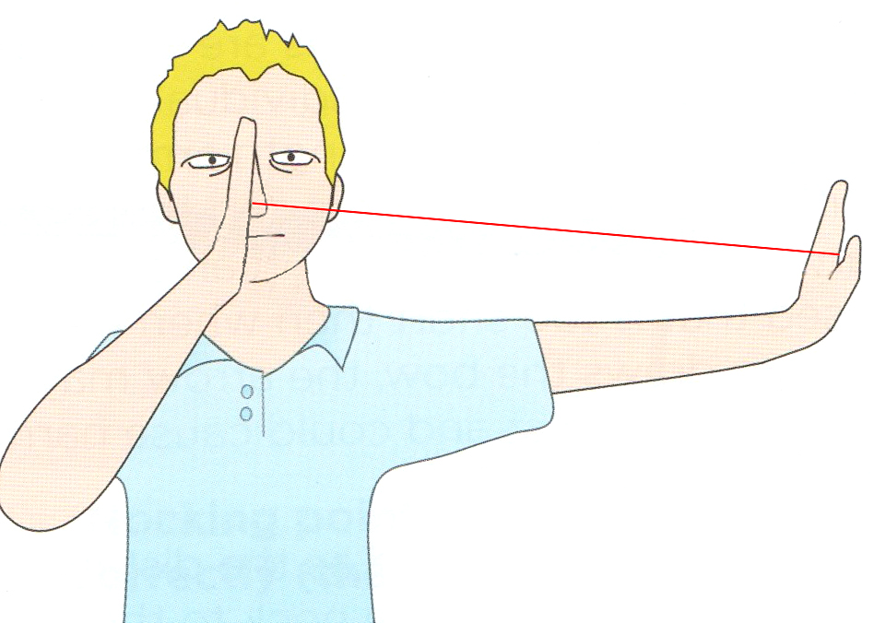
Draw Length and Arrow Length.

This diagram shows one way a coach would check that your arrows are long enough, but we cannot do that, so you will have to measure the length, so we can pick the right arrows.
Your bow hand is the opposite to your writing hand. Grip the end of a tape measure between your thumb on your bow hand and side of your hand. Pull the other end of the tape to the tip of your nose. Make sure your bow arm is straight out to the side and you are looking forward. Grip the tape at the tip of your nose and read off the measurement.
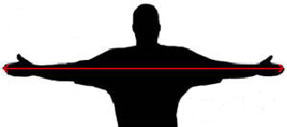

An alternative method is to measure your arm-span and divide by 2.5. Stand with your arms apart at shoulder height and measure from fingertip to fingertip.

We will use your draw length, age, and height to find the best bow and arrows for you.

CRYSTAL PALACE BOWMEN

ARCHERY BEGINNER’S COURSE

Please complete and return this form via email to: webmaster@crystalpalacebowmen.org.uk

Name: |  | Date of Birth (if under 18):
Address: |  | Gender:
 |  | Height:
 | Post Code:
Telephone No.:
E-mail address:
Previous archery experience:
Do you write with your left or right hand?:
Measured draw length:
Do you have any medical / physical problems that might affect you whilst on the course?:

Are you registered disabled? If so, please give brief details (this helps us prepare properly to work with you so your first session is not wasted):
Please tick to confirm that you are happy for the club to store your data:

Please pay for the course in advanced, either by a cheque made payable to Crystal Palace Bowmen, or alternatively, you may pay by online banking electronic transfer with the following details:

Account Name: Crystal Palace Bowmen
Sort Code: 30-84-51
Account Number: 31146668
Your Reference: please enter your initial and surname as reference

Should you be unable to return the form electronically, then please post to the Club’s Secretary:

Lewis Brown
Crystal Palace Bowmen
164 Lullingstone Crescent
Orpington
Kent
BR5 3DU

Tel: 0208 325 9745
Cell: 07890 756983
Email: secretary@crystalpalacebowmen.org.uk

